A

DISSERTATION REPORT

ON

“OFF-ROADING ROVER”

SUBMITTED IN PARTIAL FULFILLMENT OF

THE REQUIREMENT FOR THE AWARD OF DEGREE OF

BACHLOR OF TECHNOLOGY

IN

**MECHANICAL ENGINEERING**

OF

**“DR.BABASAHEB AMBEDKAR TECHNOLOGICAL UNIVERSITY,LONERE.”**

SUBMITTED BY

**MR.SHINDE NIKHIL MILIND**

**MR.GAIKWAD JAYDIP DHANAJI**

**MR.SALUNKHE DHAIRSHIL ANKUSH**

**MR.LOHAR SUDARSHAN SHUBASH**

**MR.GHATAGE VISHWAJEET LAXMAN**

UNDER THE GUIDANCE OF

**Prof. KANASE.A.B.**



**DEPARTMENT OF MECHANICAL ENGINEERING**

SHREE SANTKRUPA INSTITUTE OF ENGINEERING & TECHNOLOGY,

Ghogaon, Dist. Satara (M.S.)

2021- 2022

SHREE SANTKRUPA INSTITUTE OF ENGINEERING &TECHNOLOGY,

Ghogaon, Dist. Satara (M.S.)

**DEPARTMENT OF MECHANICAL ENGINEERING**

CERTIFICATE

**This is to certify that the seminar report entitled**

**“**OFF-ROADING ROVER**”**

**is a bonafide work**

**of**

**Mr.Shinde Nikhil Milind**

**Mr.Gaikwad Jaydip Dhanaji**

**Mr.Salunkhe Dhairyashil ankush**

**Mr.Lohar Sudarshan Subhash**

**Mr.Ghatage Vishwajeet Laxman**

**in the partial fulfillment of the requirements for the award of Degree of Bachelor Of Technology in Mechanical Engineering**

**of**

**Dr.Babasaheb Ambedkar Technological University,Lonere.**

**He has carried out the work under my supervision and guidance, during academic year 2021-2022 and to the best of our knowledge the work reported herein does not form the part of any other thesis or dissertation.**

**Prof.Kanase.A.B.**  **Prof.B.Y.Bhosale.** (Project Guide) Head(Department of Mech.Engg.)

**Dr.S.B.Kulkarni External Examinar**

Principal

(SSIET,Ghogaon)

**Date:**

**Place:**

**DECLARATION**

I hereby declare that I have formed, completed and written the Project entitled“**OFF-ROADING ROVER”.** It has not been previously submitted for the basis of the award of any degree or diploma or other similar title of this for any other diploma/examining body or university.

|  |  |  |
| --- | --- | --- |
| Sr.No | Name of Student’s (B,Tech,Mechanical Engineering) | Signature |
|  | MR.SHINDE NIKHIL MILIND |  |
|  | MR.GAIKWAD JAYDIP DHANAJI |  |
|  | MR.SALUNKHE DHAIRYASHIL ANKUSH |  |
|  | MR.LOHAR SUDARSHAN LOHAR |  |
|  | MR.GHATAGE VISHWAJEET LAXMAN |  |

**Date:**

**Place:**

**ACKNOWLEDGEMENT**

I take this opportunity to express my sincere gratitude towards my guide **Prof. KANASE A.B**.for his valuable guidance & encouragement throughout the course of the project work. His inspirations, constant endeavors and cooperation in analyzing the documents and data, resulted into timely completion of my project work successfully.

I am grateful to **Prof. Bhosale.B.Y**. **(Head, Mechanical Engg. Dept.)** Who spared his valuable time for me whenever I approached him for my work.

I would like to remain indebted to our **Principal Dr.S.B.Kulkarni**, who has been a person of constant inspiration for me, for which I feel much honored and express my sincere gratitude towards him.

Last but not the least, this acknowledgement would be incomplete without making a mention of all those who helped me in completion of this seminar, directly or indirectly.

**MR.SHINDE NIKHIL MILIND**

**MR.GAIKWAD JAYDIP DHANAJI**

**MR.SALUNKHE DHAIRYASHIL ANKUSH**

**MR.LOHAR SUDRSHAN SUBHASH**

**MR.GHATAGE VISHWAJEET LAXMAN**

**B.Tech. Mechanical Engineering**

**TABLE OF CONTENTS**

ABSTRACT ..1

CHAPTER1 INTRODUCTION………………………………………………………….…2

CHAPTER 2 METHODOLOGY ..3

* 1. Literature review ..3
  2. Objective ..4
  3. Significance ..4
  4. History of Rocker Bogie mechanism ..5
  5. Study Design ..8
  6. Design of rocker bogie mechanism…………………………………...13
  7. Gantt Chart 15

CHAPTER 3 BUDGET EXPENDITURE 16

CHAPTER 4 LIMITATIO AND PROBLEMS ENCOUNTERED 17

4.1 Limitation……………………………………………………………..17

4.2 Problems Encountered………………………………………………...17

CHAPTER 5 CONCLUSION & RECOMMENDATION 18

REFERENCES …………...19

# 

# 

# LIST OF FIGURE

# Figure 1: First Planetary Exploration Rover "Lunokhod"………...………..6

# Figure 2: NASA-JPL Sojourner Rover……………………………….………6

# Figure 3: Rocky Rover…………………………………………………….……7

# Figure 4: Sample Return Rover………………………………………….….…7

# Figure 5: PVC Pipe………………………………………………………….…10

# Figure 6: Motors..………………………………………………………….…..10

# Figure 7: Wheels………………………………………………………….……10

# Figure 8: Arduino……………………………………………………….……..11

# Figure 9: Motors………………………………………………………….……11

# Figure 10: Nuts and Bolts……………………………………………………..11

# Figure 11: Jumping Wires…………………………………………………….12

# Figure 12: Rocker Bogie……………………………………………………….13

# LIST OF TABLES

**Table 1** Gantt chart 12

**Table 2** Budget Expenditure 13

# ABSTRACT

Rocker bogie’s current mobility designs are complex, using many wheels or legs. They are open to mechanical failure caused by the harsh environment on Mars. These rovers of number of wheels (as manufactured) are capable of traversing rough terrain using an efficient high degree of mobility suspension system. The primary mechanical feature of the rocker bogie design is its drive train simplicity, which is accomplished by using only two motors for mobility. Both motors are located inside the body where thermal variation is kept to a minimum, increasing reliability and efficiency. Four wheels are used because there are few obstacles on natural terrain that require both front wheels of the rover to climb simultaneously. A series of mobility experiments in the agriculture land, rough roads, inclined, stairs and obstacles surfaces concluded that rocker bogie can achieve some distance traverses on field.so moving with the time and requirement its parameters are highly optimized resulting in great and innovative designs. To design a mechanism that can traverses terrains where the left and right rockers individually climb the different obstacle. To sustain a tilt of over 50deg without tipping over the sideways.

# 

# CHAPTER 1 INTRODUCTION

## Introduction

Over the past decade, the rocker-bogie suspension design has become a proven mobility application known for its superior vehicle stability and obstacle-climbing capability. Following several technology and research rover implementations, the system was part of Mars Pathfinder’s Sojourner rover. When the Mars Exploration Rover (MER) Project was first proposed, the use of a rocker-bogie suspension was the obvious choice due to its extensive heritage. The challenge posed by ME was to design a lightweight rocker-bogie suspension that would permit the mobility to stow within the limited space available and deploy into a configuration that the rover could then safely use to egress from the lander and explore part of Mars Pathfinder’s Sojourner rover. When the Mars successfully flown as Mars Exploration Rover (MER) Project was first proposed, the use of a rocker-bogie suspension was the obvious choice due to its extensive heritage. The challenge posed by MER was to design a lightweight rocker-bogie suspension that would permit the mobility to stow within the limited space available and deploy into a configuration that the rover could then safely use to egress from the lander and explore the Martian surface. When building a robot you’d like it to be as simple as possible. In most cases you'd never need a suspension system, but there were several instances when a suspension system cannot be avoided. The term “bogie” refers to the links that have a drive wheel at each end. Bogies were commonly used as load wheels in the tracks of army tanks as idlers distributing the load over the terrain. Bogies were also quite commonly used on the trailers of semi-trailer trucks. Both applications now prefer trailing arm suspensions. The rocker-bogie design has no springs or stub axles for each wheel, allowing the rover to climb over obstacles, such as rocks, that are up to twice the wheel's diameter in size while keeping all six wheels on the ground. As with any suspension system, the tilt stability is limited by the height of the center of gravity.

## CHAPTER 2 METHODOLOGY

## 2.1Literature review

## Abhishek Verma, Chandrajeet Yadav, Bandana Singh, Arpit Gupta, Jaya Mishra, Abhishek Saxena.

## The concept of our research work is to create a rocker bogie drive system based on those of NASA. NASA developed the rocker-bogie suspension system for their rovers and was implemented in the Mars Pathfinder's and Sojourner rover. The rocker-bogie suspension system passively keeps all six wheels to the robot in contact with the ground even on uneven surfaces. This creates for great traction and maneuverability (Harrington & Voorhees).The rocker-bogie suspension mechanism which was currently NASA’s approved design for wheeled mobile robots, mainly because it had study or resilient capabilities to deal with obstacles and because it uniformly distributes the payload over its 6 wheels at all times. It also can be used for other purposes to operate in rough roads and to climb the steps. It was having lots of advantages but one of the major disadvantages is the rotation of the mechanism when and where is required. The rotation can be possible by providing individual motors to individual wheels which causes arise in cost and complicacy in design. Here an attempt was made to modify the existing design by incorporating a gear type steering mechanism which will be operated by a single motor which simplifies the design as well as the total cost d operating cost of the mechanism.

## 

## 2.2 Objective

* The objective of this project is to design a small, robust and highly maneuverable rover robot. It will be designed for working on the different platforms like rough terrains, smooth surfaces, overcoming obstacles in its path.
* Climbing over obstacles of certain height.
* To design and fabricate a Rocker Bogie mechanism.
* To know the use of different machines during manufacturing process.

## 2.3 Significance

## We could develop it into a Wheel Chair too. It can be send in valleys, jungles or such places where humans may face some danger.

## With the development in technology the rover can be used for scouting purposes with the cameras installed on the rover and minimizing the size of rover.

## With some developments like attaching arms to the rover it can be made useful for the Bomb Diffusing Squad such that it can be able to cut the wires for diffusing the bomb.

## By the development of a bigger model it can be used for transporting man and material through a rough terrain or obstacles containing regions like stairs.

## It can also be developed into Suspension System for the automobile vehicles through proper research.

## 2.4 History of Rocker Bogie mechanism:

The rocker- bogie system is the suspension arrangement developed in 1988 for use in NASA’s Mars rover sojourner and which has since become NASA's favored design for rovers. It has been used in the 2003 mass exploration robe mission robots spirit and Opportunity, on the 2012 Mars Science Laboratory mission's rover Curiosity and is slated for use in the Mars 2020 rover.

The "rocker" part of the term comes from the rocking aspect of the larger, forward leg on each side of the suspension system. These rockers are connected to each other and the vehicle chassis through a differential. Relative to the chassis, when one rocker goes up, the other goes down. The chassis maintains the average pitch angle of both rockers. One end of a rocker is fitted with a drive wheel, and the other end is pivoted to the bogie.

The "bogie" part of the term refers to the smaller, rearward leg that pivots to the rocker in the middle and which has a drive wheel at each end. Bogies were commonly used as load wheels in tracks of army tanks as idlers distributing the load over the terrain, and were also quite commonly used in trailers of semi-trailer trucks. Both tanks and semi-trailers now prefer trailing arm suspensions.

**1.LUNOKHOD**

The first planetary exploration rover was “Lunakhod” which has been sent Moon2 times with USSR – Luna missions to gather information around landing site and send pictures of terrain. Lunakhod has guided in real-time by a five-person team at the Deep Space Center near Moscow, USSR. Lunakhod-2 toured the lunar Mare Imbrium for 11 months in one of the greatest successes travelled 37 km on Moon surface.

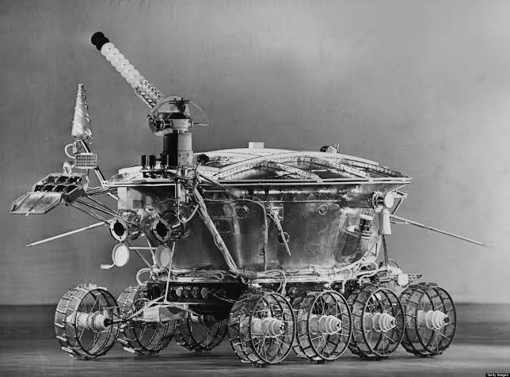

Fig. First Planetary Exploration Rover “Lunokhod”

**2. SOJOURNER**

In 1996, NASA – Jet Propulsion Laboratory and California Institute of Technology have designed new rovers with identical structure named Sojourner and Marie-Curie. These small rovers were only 10.5 kilograms and microwave were oversized Rover Sojourner launched with Pathfinder landing module in December 1996. NASA - JPL Sojourner Rove

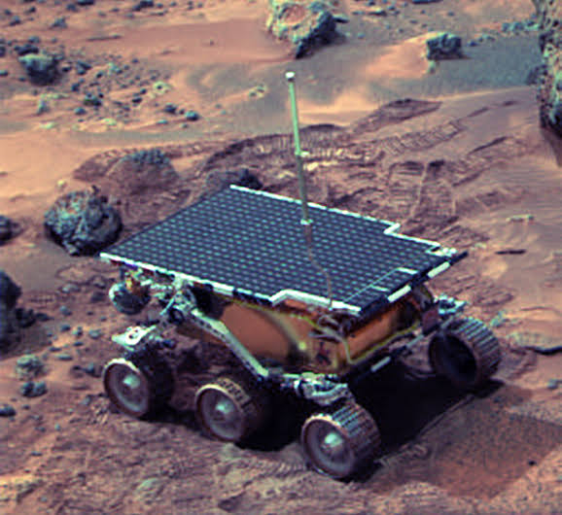

Fig. NASA - JPL Sojourner Rover

**3. ROCKY 7**

Rocky 7’s design and dimension are similar to sojouner. A robotic arm is attached to the body for investigation. Mobility system changed to two wheel steering similar ti Ackerman type. Although this modification decreases the complexity for control system.

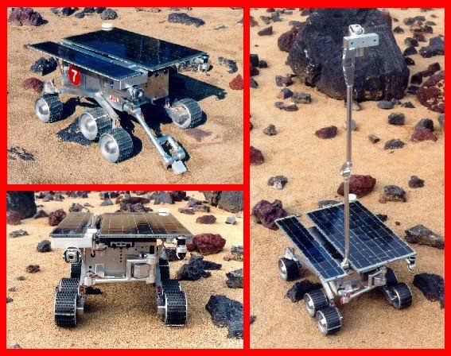

Fig. Rocky 7 rover

**4.** **SAMPLE RETURN ROVER**

Rough terrain mobility of mobile robot can be increased by center of gravity shifting method . A good example to this category is NASA Sample Return Rover (SRR) which has been designed to collect soil and stone sample from Mars surface. SRR has active suspension system with variable angle between linkages.

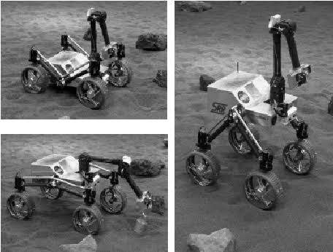

Fig. Sample return rover

## 2.5 Study Design

Need Assessment

Literature Review

Design

Materials Collection

Fabrication

Testing

Demonstration

The study design of the Rocker Bogie Mechanism Design the prototype in correct manner.

* Consult with supervisor and coordinator for the budget estimation and materials.
* Identify and finalize the required tools.
* Collect the required tools.
* Manage the materials in correct shape and size.
* Fitting of frame smoothly and creatively.
* Test the sample at the University

## 2.6 DESIGN OF ROCKER BOGIE MECHANISM

The design of rocker bogie was done by using the Computer Aided Design.

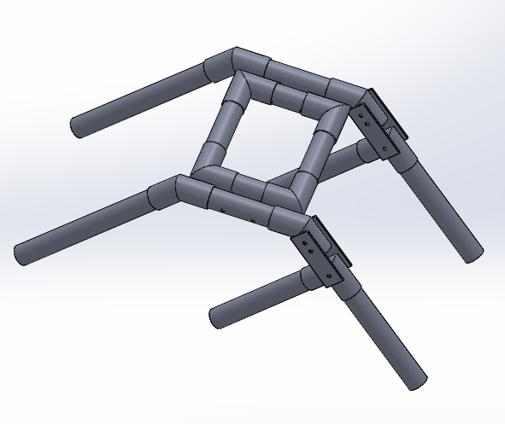

* **MATERIAL SELECTION**

Various materials were selected each with the specific purpose. The material to be used were found in the local market.

## FABRICATION

Fabrication of the various part such as PVC pipe frames etc. were done by Machining and by using Mechanical devices.

## ASSEMBLY

In this part, different component of Rocker Bogie were assembled from fabricated component (RF 2.4Ghz multi channel wireless PS2 remote, motor driver pipe frame,) by using solution, nut &bolts.

## TESTING

Testing of the project was done by moving it on unbalanced surface and performance was noted.

**Total operation time**: Maximum 25 min according to battery capacity.

**MATERIALS**:

1. **PVC pipes** for outer frame.

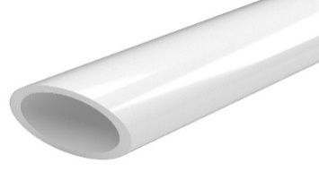

Figure 1: PVC Pipe

1. **Motors** for run wheels.

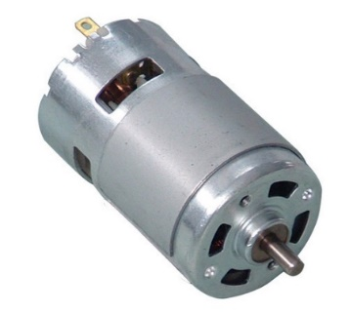

Figure 2: Motors

1. 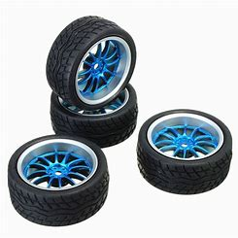**Wheels** for giving motion to bogie.

Figure 3: Wheels

1. **Arduino** for controlling bogie through mobile phone.

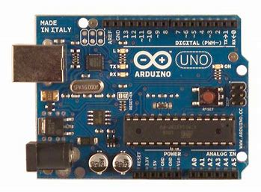

Figure 4: Arduino

1. 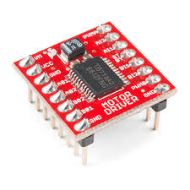**Motors driver** for operates the motors.

Figure 5: Motors

1. **Nuts & Bolts** for fixing the outer frame.

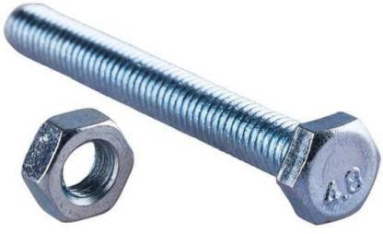

Figure 6: Nuts and Bolts

1. **Jumping Wires** for connecting arduino, motors driver.

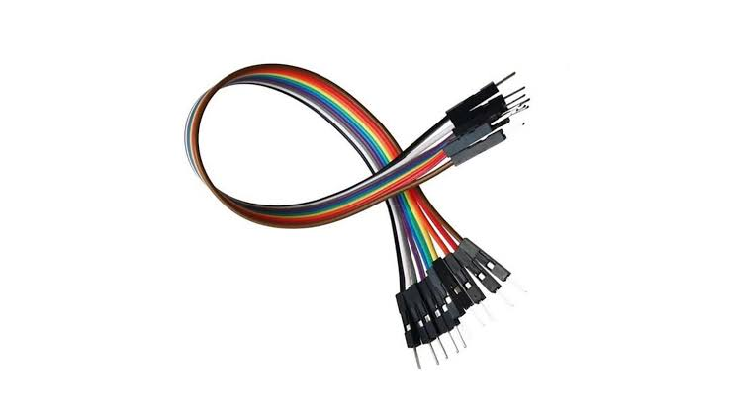

Figure 7: Jumping Wires

## PVC pipe Specification:

1. Total pipe used :220mm
2. External diameter: 20.0mm
3. Internal diameter**:** 16mm

## Final Outcome

## final rocker bogie

Figure 8: Rocker Bogie

So it is the final product we obtained in around thirteen weeks’ time among them around ten of them was active. The above picture is the rocker bogie with two pairs of front arms with motors freely suspended in 90’ elbow which helps in stairs and obstacles climbing. And there are two rigid rear arms which supports the locomotion.

## 2.7 Gantt Chart

|  |  |  |  |  |  |  |  |  |  |
| --- | --- | --- | --- | --- | --- | --- | --- | --- | --- |
| Weeks | 1 | 2 | 3 | 4 | 5 | 6 | 7 | 8 | 9 |
| Literature review |  |  |  |  |  |  |  |  |  |
| Consultation |  |  |  |  |  |  |  |  |  |
| Proposal Submission |  |  |  |  |  |  |  |  |  |
| Material Selection & purchase |  |  |  |  |  |  |  |  |  |
| Model Design & Construction |  |  |  |  |  |  |  |  |  |
| Midterm Presentation |  |  |  |  |  |  |  |  |  |
| Testing & Debugging |  |  |  |  |  |  |  |  |  |
| Final Report Submission & Presentation |  |  |  |  |  |  |  |  |  |
| Demonstration |  |  |  |  |  |  |  |  |  |

Table 1: Gantt chart

|  |  |
| --- | --- |
| Work completed |  |
| Work remaining |  |

**CHAPTER 3 BUDGET EXPENDITURE**

**Table 2:** **Budget Expenditure**

|  |  |  |  |  |  |
| --- | --- | --- | --- | --- | --- |
| **S/N** | **Particulars** | **Specification** | **Rate** | **Unit** | **Total**  **(NRs)** |
| **1.** | **PVC Pipes** |  | **332** | **1.5m** | **500** |
| **2.** | **Motors** | **100rpm** | **300** | **6** | **1800** |
| **3.** | **PVC joints** |  | **16** | **12** | **200** |
| **4.** | **Battery** | **12v** | **900** | **1** | **900** |
| **5.** | **Motor Driver** |  | **800** | **1** | **800** |
| **6.** | **Ardiuno** |  | **900** | **1** | **900** |
| **7.** | **Wheels** |  | **110** | **6** | **660** |
| **8.** | **Switch** |  | **40** | **1** | **40** |
| **9.** | **Others(solution,nutbolts,**  **wires, soldering)** |  | **500** |  | **500** |
|  |  |  |  | **Total** | **6200** |

# CHAPTER 4 LIMITATION AND PROBLEMS ENCOUNTERED

## 4.1 LIMITATION

# One of the major shortcomings of current rocker-bogie rovers is that they are slow. In order to be able to overcome significantly rough terrain without significant risk of flipping the vehicle or damaging the suspension, these robots move slowly and climb over the obstacles by having wheels lift each piece of the suspension over the obstacle one portion at a time.

# 4.2PROBLEMS ENCOUNTERED

1.It was difficult to fix the nut, bolts and metal strip.

2.Motor which was given from department was of different rpm so it was difficult to manage with them.

Although these problems occurred, we completed our project and ran a successful testing. We took help and supports from our seniors and friends to cope with these problems.

# 

# CHAPTER 5 CONCLUSION & RECOMMENDATION

## Conclusion

## After the completion of the project will be able

## To understand the rocker bogie mechanism and advantages we can from its bigger model and commercialization.

## We learned to work with the mechanical tools.

## We developed team working skills.

## We learned great deal of soldering skills and little bit about the microcontrollers, RF modules and its mechanisms.

## Recommendation

* We should use our electronic item very carefully to avoid short circuit.
* Motors should be use of same rpm and voltage.

# REFERENCES

|  |  |
| --- | --- |
| [1] | [Online].Available: <https://l.facebook.com/l.php?u=https%3A%2F%2Fwww.researchgate.net%2Fpublication%2F313403109_Design_of_Rocker_Bogie_Mechanism%3Ffbclid%3DIwAR2slczzBEzRm7ShRc4g5azNGh4FZfjGEn1ptfszDVv2UtWtF9kGG4YGyw&h=AT072tgdpSwvQGFZOy3ceIfrEuIGJXAwQBhLgyhVFiKTiKe4khv5iW4.> |
| [2] | “. C. o. D. t. R.-B. S. f. t. M. E. R. P. o. t. 3. A. M. S. J. S. C. p. N. 1.-1. M. 1.-2. 2. B. D. Harrington and C. Voorhees. |
| [3] | A. B. R. R. &. R. K. S. “. o. M. G. T. S. M. t. R. B. I. J. o. I. R. (. V.-2. I.-5. I. 2.-1. P. Panigrahi. |
| [4] | "Pipe," [Online]. Available: https://furnituregradepvc.com/products/1-1-2-in-schedule-40-pvc-pipe-bundle-of-100-feet-custom-cut. |
| [5] | "Motor," [Online]. Available: https://www.indiamart.com/proddetail/dc-motor-2120393155.html. |
| [6] | "Wheels,"[Online].Available: https://ae01.alicdn.com/kf/HTB1g13qGxWYBuNjy1zkq6xGGpXac/4Pcs-Rubber-RC-Flat-Racing-Car-Tires-On-Road-Wheel-12-spoke-Wheel-Rim-For-Robots.jpg. |
| [7] | "Ardiuno," [Online]. Available: https://www.arduino.cc/en/uploads/Main/ArduinoUnoFront.jpg. |
| [8] | "Nuts," [Online]. Available: https://www.sparkfun.com/products/14450. |
| [9] | "Bolts,"[Online].Available: www.tomcatwebshop.co.uk/ekmps/shops/tomcatwebshop/images/radius-arm-fixing-bolt-and-nut-6302-509-p.jpg. |
| [10] | [Online]. Available: https://www.indiamart.com/proddetail/dc-motor-2120393155.html. |
| [11] | "Bluetoothmodule,"[Online].Available: content/uploads/2014/04/4110_large_jumper_wires_20cm_mm_pack_10.jhttps://www.diyelectronics.co.za/store/6125-thickbox_default/jdy-08-cc2541-bluetooth-40-ble-serial-m. |
|  |  |